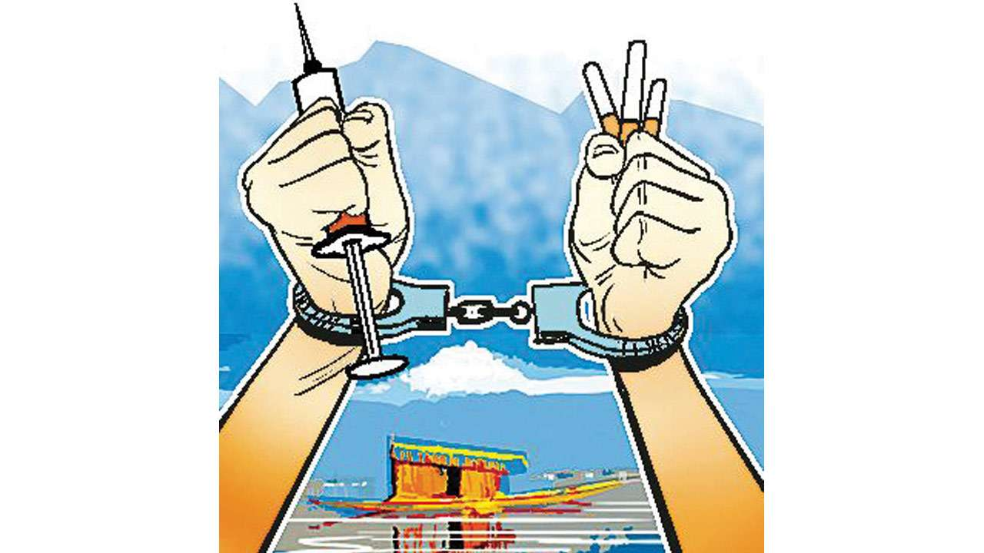

The Impact of Drug Trafficking in Bangladesh

Title of the Report

The Impact of Drug Trafficking and Drug Abuse in Bangladesh

Submitted to

Md. Iftekharul Amin

Associate Professor,

Institute of Business Administration,

University of Dhaka.

Submitted by

Mushfiqur Rahman Chowdhury

BSSE 1110

Institute of Information Technology (IIT),

University of Dhaka.

Course Code: **BUS 503**

LETTER OF TRANSMITTAL

Md. Iftekharul Amin

Associate Professor,

Institute of Business Administration,

University of Dhaka.

Subject: The Impact of Drug Trafficking and Drug Abuse in Bangladesh

Dear Sir,

With due respect, I am pleased to submit the final report on The Impact of Drug Trafficking and Drug Abuse in Bangladesh. Although this report may have shortcomings, I tried my level best to produce an acceptable report. I would be highly obliged if you overlooked my mistakes and accepted my effort.

Sincerely yours,

Mushfiqur Rahman Chowdhury

BSSE 1110,

Institute of Information Technology,

University of Dhaka.

Acknowledgement

I am highly indebted for getting such a tremendous opportunity to  prepare the report on The Impact of Drug Trafficking and Drug Abuse in Bangladesh. I would like to thank whole-heartedly our course teacher,  Md. Iftekharul Amin, Associate Professor, Institute of Business  Administration, University of Dhaka, for giving us guidelines about how  we can prepare this report. In completing this paper, I have collected  various important data and information from different websites, blogs and articles. I am thankful to all of the works cited.

 Chapter 1:

Introduction

1.1 Origin of the Report

Drug trafficking is a global illicit trade involving the cultivation, manufacture, distribution and sale of substances which are subject to drug prohibition laws. The term drug abuse refers to the excessive or addictive use of drugs. In Bangladesh, it is an acute problem because of its geographical location.

The geographical location of Bangladesh is at the crucial point between the ‘golden triangle’ (Myanmar, Thailand and Laos) and 'golden crescent' (Pakistan, Afghanistan and Iran). The country is also surrounded by major drug producing countries of Asia making Bangladesh an easy transit point due to its easy access of land, sea and air. The increasing problem of drug trafficking in Bangladesh is keeping a major impact on its economy. (<https://academicjournals.org/journal/IJSA/article-full-text-pdf/E06E1EC66510>)

(SSRN)

The study was conducted to understand the impact of drug trafficking and drug abuse from the economic and social perspective of Bangladesh.

1.2 Objectives of This Study

The major objective of the study is to discuss the impacts of Drug Trafficking and abuse in Bangladesh.

**Specific objectives-**

• Discuss the existing why Bangladesh is at a high risk of getting affected due to drug trafficking and abuse.

• Show how important it is to create resistance against the impacts of Drug Abuse in Bangladesh.

1.3 Scope of This Report

This report will focus on the socio-economic impacts of drug trafficking and abuse in Bangladesh and highlight the necessity of effective measure against drug trafficking and abuse in Bangladesh.

1.4 Limitations of the Study

Although I have tried my best to accomplish the goal of this project, there were a few  limitations I had to face. I personally didn’t get to interview any sociologist, economist, drug addict or trafficker in person. I have gathered the  information through websites, blogs, research papers and articles published.

1.5 Rationale of the Study

* Data regarding drug trafficking and abuse situation in Bangladesh is scarce and not well summed up. This study tries to sum up the findings of very few studies carried out on this issue.
* With time, drug trafficking is becoming more and more an important issue to address efficiently. This study tries to find out answers to some relevant questions regarding the issue.

1.6 Methodology of the study

The study is conducted through secondary data collection. I have collected data from relevant research papers, articles and reports I found on the internet about this issue.

1.7 Chapter Summary

This chapter shows the origin of the report, the objective of the report, the scope and limitations, rationale of the report and the methodology. Drug Trafficking and Abuse is a global problem. But it is a more serious issue in third world countries like Bangladesh where the legal system is not strongly developed and the poor economy will rush into the dirty business of drugs. Systematic studies need to be executed in order to identify where and how we can improve in order to address this problem with efficiency. This is high time we cared for the prevention of drug trafficking and abuse as much as we care for the other problems which impact our society and economy. Otherwise it will not be possible to overcome the poverty and other increasing social problems in Bangladesh.

Chapter 2:

Background of Drug  Trafficking and abuse

This chapter focuses on the recent findings regarding drug trafficking and abuse in the prospect of Bangladesh.

## 2.1 Root Causes of Drug Trafficking in Bangladesh

Bangladesh is surrounded by India from three sides. The geographical location makes Bangladesh a transit point of many drug producing countries beyond its borders. There are many hilly regions around Bangladesh which provide convenient scope for the Drug Traffickers to conceal themselves. The easy access to land, sea and air of Bangladesh raises further opportunities for drug trafficking and abuse.

The Border Guard of Bangladesh (BGB) and other enforcement agencies of Bangladesh has developed an evil alliance with the drug dealers making it difficult to run operations against drug traffickers. The dishonesty of responsible personalities on this matter is leading to information leakage and the escape for the traffickers.

## 2.2 Availability of Drugs

Among the various types of drugs available, three major categories are:

A. Opium: Heroin, Phensidyl, Tidijesic, Pethidine,

B. Cannabis: Ganja, Chorosh, Bhang

C. Sleeping pill: Tranquilizer, Seduxene (Diazepam)

D. Methamphetamine: Yaba,etc.

## 2.3 Methods of Drug Trafficking

* In general, drug traffickers maintain some method for the trafficking of drugs. The drug containers are transported by land or sea. Sometimes, vehicles are also used for the purpose; engine compartment, boot of a car or the petrol tank, etc areas are commonly used in south Asia.
* Consignments of drugs are hidden in tin boxes, luggages, in fruit and coconuts.
* Drugs are even concealed within the human body for trafficking.
* In Bangladesh, three major methods are followed by the traffickers which are:

1. Through Courier from Pakistan to Bangladesh;
2. Through any Commercial vehicle or train from India;
3. Using sea route from Bay of Bengal or by road from Myanmar.

## 2.4 Interrelationship between Drug Abuse and Money Laundering

 The connection with narcotics and money laundering is particularly common, because often millions of dollars constitute the proceeds of a drug sale or number of sales, which then have to be integrated back into legitimate business ventures, investments, bank accounts, securities investments, gold, stocks and other legitimate capital. The drug traders who are involved in the trafficking often use influences of political powers to launder their money abroad or inside the country.

Drug abuse is an alarming problem in Bangladesh. The amount of money drug abusers spend per year is much higher than the per-capita income of Bangladeshi people (US$ 380)(according to 2001 Data) . Furthermore, the total money spent by 1.7 million drug abusers might be around US$ 1.2-1.9 billion in Bangladesh. (Pg-98-99) (<https://tspace.library.utoronto.ca/bitstream/1807/50049/1/hn04013.pdf?fbclid=IwAR0T_mpMKLlaDLjNjA6TN-SymUqBEsNTXo4dpizPOSX1UqHUM52k6riW6sA>)

## 2.5 Chapter Summary

This chapter focuses on the existing situation of drug trafficking and abuse in Bangladesh. The beginning the chapter discusses the root causes of drug abuse and then moves towards different types of drugs available in the country, Gradually the chapter moved on to availability and methods of drug abuse and how the drug money is laundered in recent times.

Chapter 3:

Impact of Drug  Trafficking and abuse

## 3.1 Impact on the student context, employment and productivity

The phenomenon of drug abuse occurs more frequently among young people in the 15-35 age group, which is more concentrated in the 18-25 age group. It mostly includes people who entered or are just about to enter their professional life. The high unemployment rates in many countries are often related to the entry into the workforce. Consumption of illicit drugs limits the opportunities of entering or remaining in the workforce. In the meantime, frustration caused by failure to find adequate employment favors drug consumption, thus creating a dangerous cycle of unemployment.

Recent studies, all over the world, are presenting very worrying numbers about the use/abuse of drugs by university students. The students of both public and private universities in Bangladesh are also prone to such abuse of drugs due to frustration caused by poverty, failure in academics and excess stress in their academic life.

The 1993 national household survey carried out in Colombia, showed that the annual 17% prevalence of drug abuse among the unemployed (4.1 per cent) was almost four times higher than among the employed (1.1 per cent). According to the statistics, Bangladesh as a country which is prone to unemployment and overpopulation, it can be prone to serious threats of drug abuse. (https://www.unodc.org/pdf/technical_series_1998-01-01_1.pdf)

## 3.2 Social Impact

## Illicit drug abuse relates more evidently with the disintegration of the family compared to that of poverty. Family factors might intensify drug abuse by- prolonged or traumatic parental absence, failure to communicate on an emotional level, harsh discipline, and parental use of drugs,etc. Absence of household stability along with low income  and unemployment issues also increases vulnerability to drug abuse.

The consequences of drug abuse are- permanent physical and emotional damage to users, negatively impacting their families, coworkers, and others. Drug use negatively impacts a user's health, often leading to sickness and disease. Some users are parents, whose deaths leave their children in foster care. (<https://www.unodc.org/pdf/technical_series_1998-01-01_1.pdf>) (X:Tseries)

A study shows that out of 50 civil society members, about the impact of changes in social behavior for increasing drug trafficking and abuse, the results revealed that almost all of the civil society members knew the impact of changes in social behavior. Increasing drug abuse deteriorated law and respects to elder (100.0%), lack of interest in education (82.0%), increased occurrence of hijacking (80.0%) and change in moral values (76.0%). The impact of changes in social behavior also increased the number of stealing and robbery (62.0%), and increased family expenditure (34.0%).

(<https://academicjournals.org/journal/IJSA/article-full-text-pdf/E06E1EC66510?fbclid=IwAR3-yGmuhdNyjBcc8rL1r_FOUsc3hkwZWEunfdQKWS425XM0Cdf8vbs8PUU>) (E06)

## 3.3 Impact on Crime Rate

The addiction of drugs causes the addicted to desperately gather money to buy and use drugs on a regular basis. Often, the high cost for buying drugs cannot be fulfilled by legitimate means and finds criminal ways to gather money for buying drugs. Bangladesh, as a country, has a weak law and order system and so getting into crime to gather drug money is rather easy for the drug abusers in Bangladesh.

A study conducted out of 50 civil society members of Bangladesh, regarding the source of money for buying drugs, which was a multiple response question, the results revealed that all most all of the civil society members knew the source of money for buying drugs was gotten through criminal activities like hijacking, extortion etc. (88.0%) and loan from friends, family members (80.0%), half of the civil society members knew source of money for buying drugs from pocket money (62.0%) and from own income (44.0%).

(https://academicjournals.org/journal/IJSA/article-full-text-pdf/E06E1EC66510)

## 3.4 Impact on Health

The negative impact of drug abuse on health is scientifically established depending on the dosage of substances like- opium, heroine, benzodiazepines, cannabis, etc. These substances can be associated with fatal accidents or even death. (https://www.unodc.org/pdf/technical_series_1998-01-01_1.pdf)

|  |  |  |
| --- | --- | --- |
| Drug category | Acute toxicity | Chronic toxicity |
| Cannabis (marijuana, hashish) | Psychomotor impairment; synergism with alcohol and sedatives | Apathy and mental slowing, impaired memory and learning (brain damage?), impaired immune response |
| Cocaine, amphetamines | Sympathetic overactivity: hypertension, cardiac arrhythmias, hyperthermia; acute toxic psychosis: delusions, hallucinations, paranoia, violence, anorexia | Paresthesias, stereotypy, seizures, withdrawal depression, chronic rhinitis, perforation of nasal septum |

## 3.5 Chapter Summary

This chapter focuses on the impacts of Drug Trafficking and Abuse in the diverse sectors of the country. The sectors are employment, society, crime rate and health. Firstly, the chapter highlights how the abuse of drugs hinders the productivity of young aged individuals who are at the beginning of their professional career and how getting into drug addiction puts them on a loop of unemployment. Secondly, the chapter focuses on how it affects social behavior of individuals and negatively affects society. The addiction is also leading to increase in crime in Bangladesh and seriously affecting the health of drug abusers.